Marketing Planning Assistant Agent

  - Course Name: Agentic AI

Institution Name: Medicaps University – Datagami Skill Based Course

Student Name(s) & Enrolment Number(s):
Sr no | Student Name | Enrolment Number
1. | SHRADDHA THAKUR | EN22CS301924
2. | SAIYAD ISHAN ALI | EN22CS301839
3. | AADARSH BHAWSAR | EN23CS3T1012
4. | SAMYAK LALAN | EN22CS301858
5. | ANIL KUMAR SHAH | EN22CS3L1003
6. | BADAL PATIDAR | EN22EE301005

Group Name: Group 11D8
Project Number: AAI -46
Industry Mentor Name: Aashruti Shah
University Mentor Name: Prof. Pradeep Baniya
Academic Year: 2025-2026

Problem Statement & Objectives

Problem Statement :-
- Businesses today face significant challenges in planning effective marketing strategies due to rapidly changing customer behavior, digital trends, and intense market competition.
- Marketing teams must analyze large volumes of data related to customers, competitors, and market performance, which makes the planning process complex and time-consuming.
- Most organizations still depend on manual analysis and multiple disconnected tools, leading to delays, inconsistency, and a higher risk of human errors.
- There is a lack of intelligent systems that specifically support the marketing planning stage rather than focusing only on campaign execution and reporting.
- Marketers often struggle to translate high-level business goals, such as increasing sales or improving brand visibility, into clear and actionable marketing plans.
- The absence of automated task decomposition makes it difficult to define campaign activities, schedules, and responsibilities in a structured manner.
- Small and medium-sized organizations generally lack skilled professionals and advanced analytical tools required for data-driven marketing planning.
- The growing number of digital marketing channels increases the difficulty of selecting suitable platforms and targeting the right customer segments.
- Budget allocation and resource planning across multiple channels remain challenging without intelligent decision support.
- Existing tools do not provide adaptive and goal-oriented recommendations for strategy formulation.
- Marketing plans are often static and do not easily adapt to changing market conditions or campaign performance.
- There is limited use of past campaign knowledge and organizational data to improve future marketing decisions.
- The need for continuous learning and feedback-driven improvement in marketing planning is largely unmet.
- Therefore, there is a strong requirement for an intelligent Marketing Planning Assistant Agent that can analyze objectives, decompose goals into actionable tasks, integrate data and tools, and generate adaptive, data-driven marketing strategies.
- Marketing teams frequently face difficulties in coordinating and aligning multiple stakeholders, departments, and external agencies during the planning phase, which leads to miscommunication, delays, and inconsistent campaign strategies.

Project Objectives :-
- To develop an intelligent Marketing Planning Assistant Agent that helps marketers create structured, goal-oriented, and data-driven marketing plans.
- To analyze business and campaign objectives and automatically convert them into clear and actionable marketing strategies.
- To enable automated task decomposition by breaking complex marketing goals into smaller activities such as audience selection, channel planning, content strategy, and budget allocation.
- To integrate analytical tools and available data sources for improving the accuracy and relevance of marketing recommendations.
- To design a centralized planning framework that supports decision making during the marketing strategy formulation stage.
- To maintain and utilize a knowledge base for storing past campaign information and insights to support future planning.
- To improve the overall efficiency and consistency of the marketing planning process.
- To reduce manual effort and dependency on individual expertise through intelligent automation.
- To support faster and more reliable marketing decisions using an agent-based approach.

- Scope of the Project •
- The project focuses on designing an intelligent assistant to support marketing strategy planning and decision making.
- It covers the analysis of business objectives and marketing goals to generate structured and actionable marketing plans.
- The system supports automated task decomposition for breaking complex marketing goals into manageable activities.
- The scope includes marketing channel selection, audience segmentation, content planning, and basic budget allocation support.
- It allows the use of historical campaign data and organizational knowledge to improve planning accuracy.
- The project supports integration with analytical tools for better data-driven recommendations.
- The system is limited to the planning and strategy formulation phase only.
- It does not directly handle campaign execution, advertisement publishing, or customer engagement operations.
- The project emphasizes an agent-based architecture to improve planning efficiency and consistency.
- The system is designed to adapt marketing plans based on updated inputs and feedback.

- Limitations of the Project
- The system depends on the quality and availability of input data, which may affect the accuracy of recommendations.
- Real-time market and social media data integration is limited in the short term.
- The agent provides planning and strategy support only and does not perform full campaign execution.
- Advanced personalization and deep customer behavior analysis are limited in the initial version.
- The system may require human review and validation before finalizing marketing plans.
Proposed Solution

- Key Features:
- Smart Marketing Plan Generation
- Target Audience Identification
- Marketing Goal Setting Support
- Strategy Development Assistance
- Marketing Channel Recommendations
- Budget Planning Guidance
- Campaign Planning Support
- Competitor Analysis Overview
- Performance Tracking Suggestions
- KPI Recommendation System
- Content Planning Assistance
- User-Friendly Interface
- Time-Saving Automation
- Data-Driven Insights Support
- Customizable Marketing Templates

- Overall Architecture / Workflow

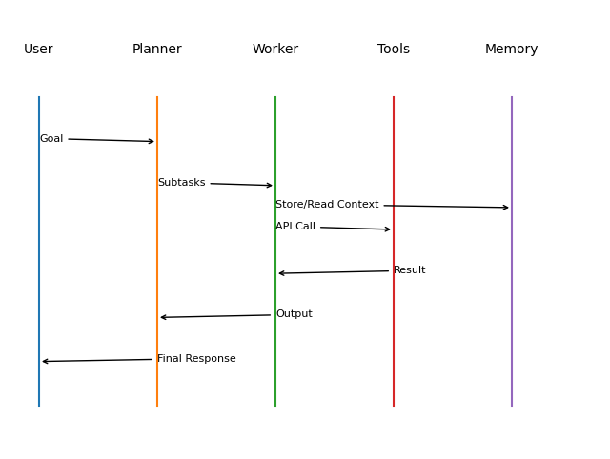

This sequence diagram shows how a user’s goal is first broken into subtasks by the Planner, then executed by the Worker using Tools and stored/read from Memory.
Finally, the processed output is sent back through the Planner to the User as the final response.

- Tools & Technologies Used :-
This project is an Agentic AI Workflow Automation System built using a Multi-Agent Architecture with tool-augmented reasoning capabilities. Unlike a traditional chatbot, it functions as a decision-making autonomous agent system capable of planning, reasoning, and executing structured workflows.
The system is developed in Python and leverages advanced AI orchestration frameworks including LangGraph (workflow orchestration), LangGraph Swarm (multi-agent communication), and LangChain (LLM integration and tool calling). It integrates with Google Gemini 2.5 Flash, a generative reasoning-based Large Language Model, through the Google Generative AI API.
The architecture follows a Planner-Worker model, consisting of:
- Planner Agent – Decomposes goals into actionable tasks
- Resource Agent – Validates budget and team availability
- Scheduler Agent – Generates execution timelines

Custom function-calling tools such as goal decomposition, budget validation, team checking, and schedule generation enhance the LLM’s reasoning and automation capabilities.
The system operates via a Command Line Interface (CLI) and uses in-memory state storage (InMemorySaver) for session-based conversation and workflow management. No external database is used.
Overall, the project demonstrates an advanced reasoning-driven, multi-agent AI automation system designed for structured task planning and execution.

Results & Output
Screenshots / outputs
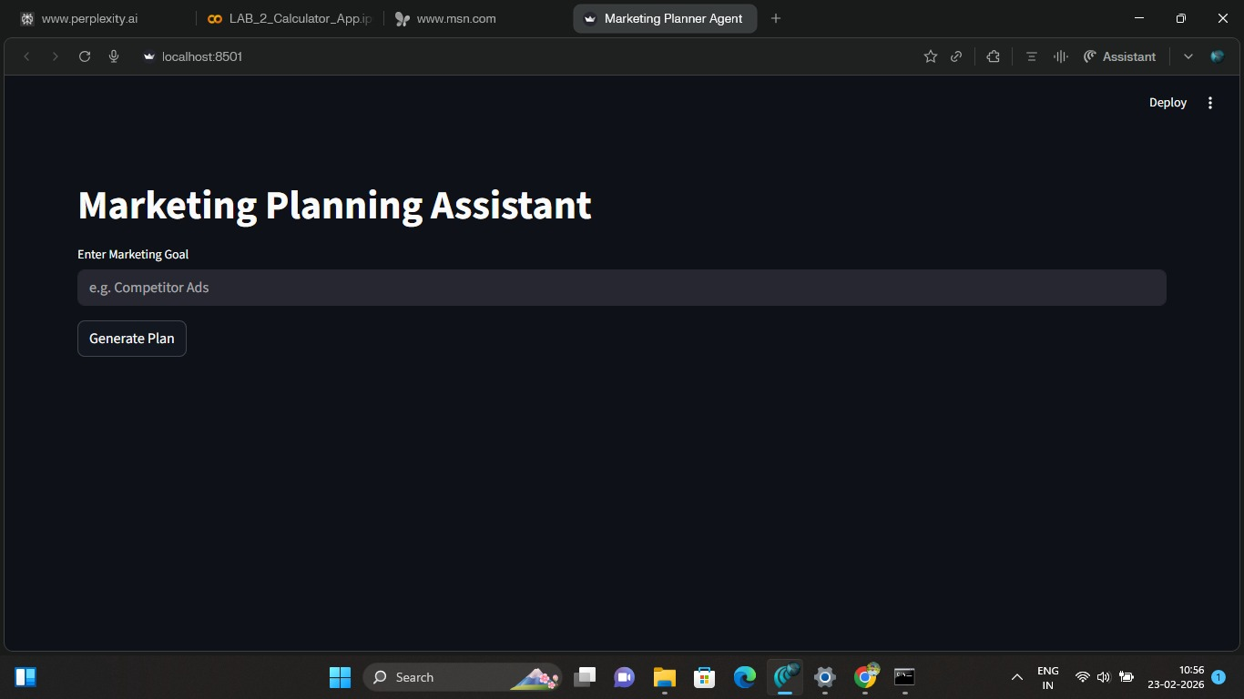
Reports / dashboards / models
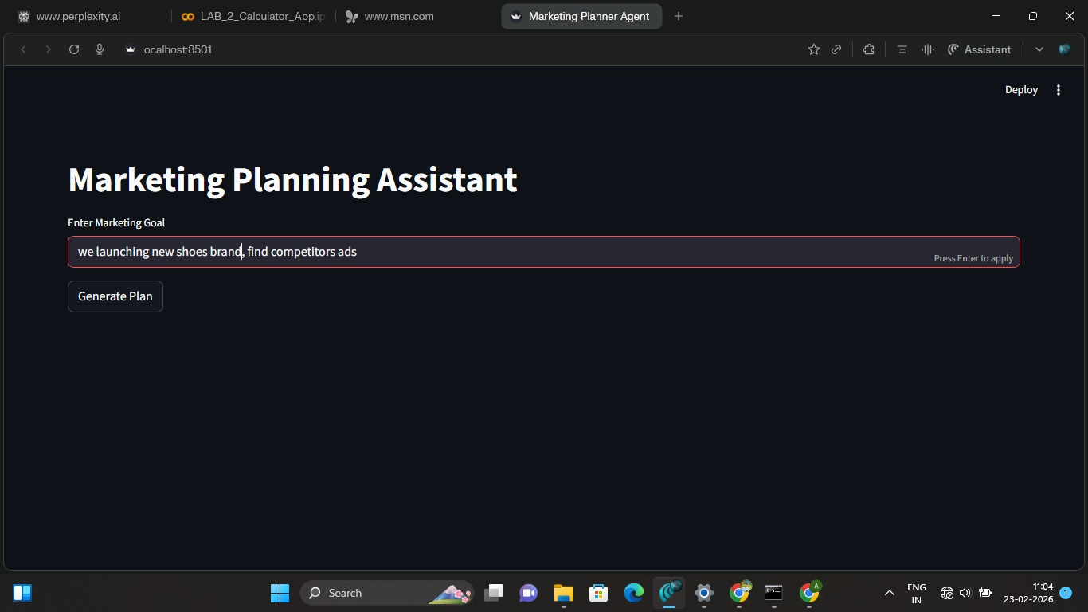
Key outcomes

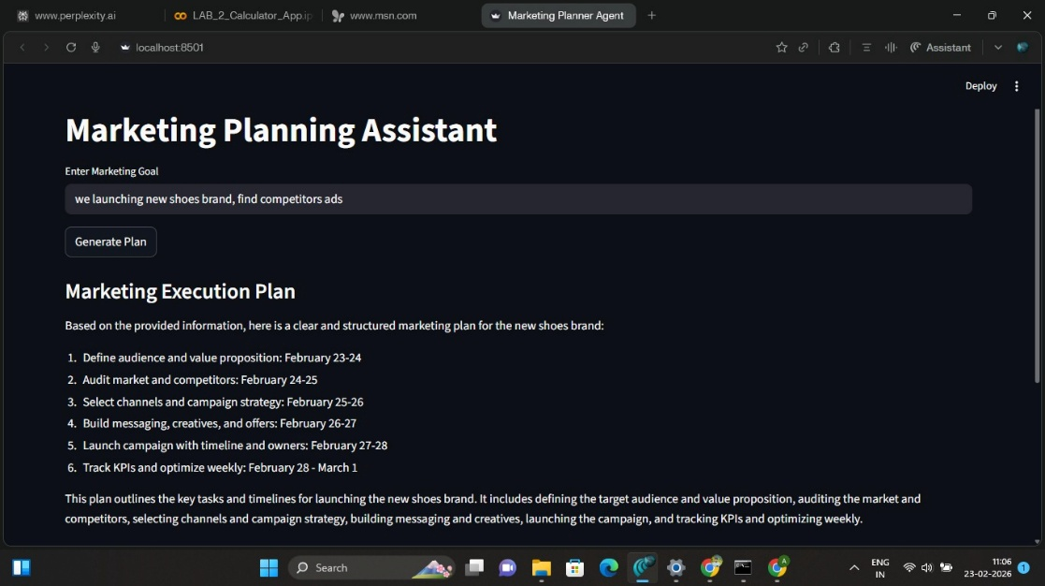

Conclusion :-
The Marketing Planning Assistant Agent provides an intelligent and structured approach to simplify and improve the marketing planning process. The system effectively supports marketers in transforming high-level business goals into clear, actionable, and data-driven marketing strategies. By using an agent-based architecture, the solution enables automated task decomposition, strategic reasoning, and organized decision support, which helps reduce manual effort and planning time. The project also demonstrates how integrating analytical tools and past campaign knowledge can enhance the quality and consistency of marketing plans. Overall, the proposed system improves planning efficiency, supports better strategic alignment, and assists organizations in responding more effectively to changing market conditions. The Marketing Planning Assistant Agent highlights the practical use of artificial intelligence in modern marketing management and establishes a strong foundation for developing intelligent, adaptive, and scalable marketing planning solutions for future business environments.

Future Scope & Enhancements
In the future, the Marketing Planning Assistant Agent can be enhanced by integrating real-time market intelligence and social media analytics to generate more timely and trend-aware marketing strategies. Advanced machine learning models can be incorporated to improve customer segmentation, demand forecasting, and campaign performance prediction. The system can be extended to support multi-channel campaign coordination, automated content suggestions, and personalized marketing recommendations. A performance monitoring dashboard can be added to continuously evaluate campaign outcomes and provide adaptive strategy updates. Furthermore, tighter integration with customer relationship management and marketing automation platforms can enable seamless transition from planning to execution. The agent can also be improved through continuous learning from user feedback and historical campaign data, making its recommendations more accurate and context-aware over time. These enhancements will help transform the system into a scalable, intelligent, and end-to-end marketing decision support platform.

